CHAPTER 1
INTRODUCTION
1.1. INTRODUCTION
The frequency and inter-area tie power should be kept close to the scheduled levels in big power systems that consist of interconnected control areas and load frequency. The frequency of the generators is controlled by the input mechanical power, and the change in frequency and tie-line power, which is a measurement of the change in rotor angle, are measured. By maintaining the frequency and voltage magnitude within acceptable ranges, a well-designed power system should be able to deliver the required levels of power quality.
Reactive power is more dependent on fluctuations in voltage magnitude than it is on frequency changes, which are more sensitive to changes in the load on the power system. Real and reactive power are thus controlled separately in the power system. While the automatic voltage regulator loop controls variations in reactive power and voltage magnitude, the load frequency control primarily controls system frequency and real power. Numerous sophisticated ideas for the large-scale control of the power system are built around load frequency control.
Due to rising demand and increased environmental awareness, the relevance of energy generation has recently increased. Additionally, it is a natural expectation of both producers and consumers to use electricity as efficiently as possible. Therefore, in order to meet the energy requirements of both energy suppliers and consumers, interconnected electrical power systems were created. Additionally, connected electrical power networks have been developed for both domestic users within the nation and with its neighbouring nations to interchange electric energy under any condition.
The connecting of interconnected electrical power networks, both inside and between countries, calls for a number of arrangements and modifications. The frequencies that can be adjusted for the entire system and all of its subsystems must be identical to one another and be internally stable. The balance between active power consumed and consumed determines the nominal frequency level in electrical power networks that are interconnected. Differences in the overall system's frequency variation can be used to identify the active power imbalance. However, given how much industrial loads connected to interconnect electrical power systems rely on high-quality electrical energy, the system's steady state frequency error must be kept within acceptable bounds.
Making the connected system's active power balance sensitive to the system frequency is presented. The nominal frequency of the system is often altered by the differential between the power output and instantaneous load change of the synchronous generators The working speed of the generators increases, which raises the frequency, if the quantity of power generated by the power systems exceeds the amount of power sought. The system frequency is also decreased if the amount of production at my location is less than the needed power. In the event of a trip, the frequency of the generators is again adjusted to restore the desired level of frequency.
To do this, a model known as the load frequency control (LFC) model, which regulates power and frequency generation in the power system based on changing demand, must be configured for every minute. By altering the microgrid sources' parameters, some research tested the IMC-based PI Controllers' robustness. For random load perturbation and random wind generator input, the two-proportional integral derivative (PID) and two-degree of freedom controller also operate satisfactorily.
In addition, a novel modelling Interline Power Flow Controller has been presented with an extra controller function to damper low frequency oscillations by taking into account these four alternative damping controllers. In order to remove the frequency variations observed in electric energy, fuzzy logic control and proportional integral derivative (PID) control viewpoints have been employed in this study's two field linked power system with variable load frequency control model.
1.2. PROBLEM IDENTIFICATION
The demand of the power is increased in daily life. Delivering high quality of electricity in variety of circumstances is the toughest challenge. Due to rising demand and increased environmental awareness, the relevance of energy generation has recently increased. Additionally, it is a natural expectation of both producers and consumers to use electricity as efficiently as possible.
Therefore, in order to meet the energy requirements of both energy suppliers and consumers, interconnected electrical power systems were created. Additionally, connected electrical power networks have been developed for both domestic users within the nation and with its neighbouring nations to interchange electric energy under any condition. if the quantity of power generated by the power systems exceeds the amount of power sought. The system frequency is also decreased if the amount of production at my location is less than the needed power. In order to remove the frequency variations observed in electric energy, fuzzy logic control and proportional integral derivative (PID) control viewpoints have been employed in this study's two field linked power system with variable load frequency control model.
1.3. OBJECTIVE OF THE THESIS
• Maintaining a largely consistent frequency, distributing the load across generators, and managing tie-line exchange schedules are the major goals of load frequency control (LFC).
• After a load shift, the steady state error should be brought to zero using load frequency control in two areas.
• Use the Pid using pso controller and fuzzy logic to decrease oscillations and the steady state shift in frequency.
1.4. ORGANISATION OF THESIS
This present thesis consists of five chapters and description of the same is as follows:
- Chapter 1, The introduction, literature survey, problem description, and objective of thesis and summary are discussed.
- Chapter 2, the introduction, reasons for frequency limits, mathematical modeling of different components are discussed.
- Chapter 3, the modeling of two area interconnected power system using fuzzy and Pid using pso in four case studies are discussed.
- Chapter 4, this chapter deals with the simulation result and discussion of four case studies.
- Chapter 5, Conclusion obtained from the work are represented in this chapter.
1.5. SUMMARY
In this chapter, Introduction, literature survey, problem description, and organization
Of the thesis are discussed.
CHAPTER 2
MODELING OF POWER SYSTEM
2.1. INTRODUCTION
Under typical operating conditions, the frequency of interconnected power systems, which include cooperating production zones, is maintained constant towards load changes and the agreed-upon power distribution across production zones. This is known as load frequency control, which entails three control phases: primary, secondary, and tertiary. According to PI, two ways have been used to speed up and regulate the load frequency control operation. A simpler structure for frequency control is shown in Figure 1 with three key control components. The large systems have three interconnected control actions, which are Primary Controlled, Secondary Controlled, and Tertiary Controlled. In a constrained environment, the secondary control is performed. The frequency regulation-based demand side management solutions are not displayed in Figure 1 in their simplest form, but they can still be assessed without any conceptual modifications.
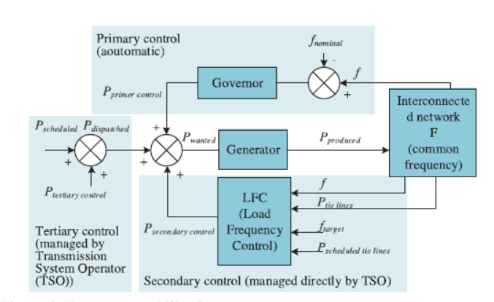
Figure 2.1. Frequency stabilization system.
There are three types of reserves that can be used to regulate frequency, which are listed below. The automatic control reserve of the system is known as the primary control reserve, which maintains the decreasing frequency level and provides a power backup against any frequency changes using a governor. The secondary control reserve provides backup power to restore the frequency level of the primary backup to its default setting, while the tertiary control reserve is used to restore the frequency to its nominal level if the secondary reserve is unable to support itself. Figure 2 shows that changes in the load of the system are always inversely proportional to changes in its operating frequency. Any increase in current will cause the operating frequency of the system to decrease. The primary control loop regulator, upon detecting a frequency shift, increases the turbine's rotational speed and production volume until the nominal frequency level is restored. Contrarily, the main control frees each production zone from the restrictions of the international agreement and enables them to grow their capacity proportionate to their output volume in order to satisfy the full load demand. To avoid any external influence on systemic production, this is done. Each production region in the connected system should not be able to satisfy its own load without transferring power to neighbouring zones.
Figure 2.2:
The flow charts for the key components of LFC for a single field power system are illustrated in Figure 3. The matrix of equations for the single area representation is elaborated. To reduce the occurrence of steady-state error, a controller with a secondary control loop can be activated. The load frequency characteristics can be achieved by following the procedure outlined in Figure 4.
Figure 2.3 shows a single area power control system in action.
The active power balance provided by the primary control ensures that the nominal frequency of the system is maintained with little error, even when the system frequency is stationary at the P0 MW load demand, and the load rises to Pi MW, as depicted in Figure 4.
When secondary control is turned on, a characteristic finally moves from "a point" to "d point," which causes the system frequency to once again be f0, its nominal value. Furthermore, information is relayed to the secondary controller using connection line load sharing, which is delivered concurrently and depends on the agreement between production zones in the connected system. It is important to define an interconnection line between the load frequency control systems of two areas in order to monitor deviations both inside the system and in nearby zones. This situation is demonstrated in Figure 5.
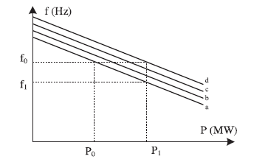
Figure 2 4: Charge frequency control characteristic of two areas

Figure 2.5: Load frequency control systems for two areas
Equations of two areas load frequency control system can be given as follows [23]:

  - OBJECTIVES OF LOAD FREQUENCY CONTROL

    - Load frequency control has fallowing objectives:

- Each area must keep the tie-line power flow at the predetermined level.
- The formation of the area control error (ACE) is the initial step in the load frequency control.
- Where the constant Bf is known as the frequency bias constant and Ptie and Psch, respectively, are the tie-line power and scheduled power through the tie-line.
- The feedback from the ACE is then received by an integral controller, where Ki is the integral gain, to adjust the reference of the power setting of the area-i.
- If a region's net power flow is low, its frequency has dropped, or both, the ACE is negative.
- To fulfil the load demand in this scenario, the generation must be raised. Pr can be raised to accomplish this.
- His negative sign explains why there is an inverse relationship between Pref, i, and ACE. Flow of power through the tie-line and
- Each region's control center monitors the frequency of each area. Following the computation of the ACE and the acquisition of Pref from Eq (2),
- Different turbine-generator controllers are given instructions to change the settings for their reference power.
- Two single area systems are connected by tie-lines to form a two area power system. It is vital to model the system mathematically before developing any control strategies. Conveniently, it is assumed that each
- An comparable turbine, speed regulation system, generator, and load can represent the control area. The single-area power system block diagram.

2.3 ADVANTAGES OF INTERCONNECTION:
2.3.1 Effects of size:
The sum in One of the most significant benefits for the entire integrated power system is this one. The required energy is initially briefly borrowed from the system kinetic energy when a load block is added. Energy is typically more readily available for larger systems. Therefore, there is a relative decrease in static frequency. The frequency drop for the same load change may be slightly higher for a single area power system.
2.3.2 Need or reduced reverse capacity:
The ratio between load peak and load average is less for large power systems compared to smaller ones since peak demands do not have a set time and can occur at any random moment of the day in numerous places. It follows that a reduced requirement for capacity reserved by the planned organisation of interchanging energy may benefit all sections of the interconnected power system.

2.4 LOAD FREQUENCY CONTROL
• At steady state, the difference in generated power and instant load demand results in a change in nominal system frequency. The speed and frequency of the generator units start to drop if the amount of power generated is less than the amount needed, and vice versa.
Therefore, in order to maintain that balance, the amount of production from the synchronous generators is made sense for frequency fluctuations in the power system.
• The frequency typically varies between low load and high load settings by roughly 5%.
• If two machines operating in parallel, as indicated below, handle a change in load.
• The method of regulation is referred to as flat frequency regulation if the change in load occurs either at S1 (or) S2, and if the generation of S1 alone is regulated to accommodate this change such that there is a constant frequency.
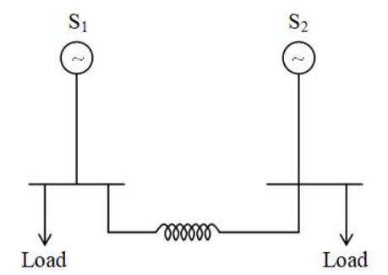
Figure 2.6: two area interconnected system
• Alternately, S1 and S2 might regulate their generation to keep the frequency constant by sharing the change in load. Parallel frequency regulation refers to this.The generator in that location takes care of the change in that area, keeping the tie-line loading constant. The flat-tie line loading control method is one of controlling the generation to maintain a steady frequency.
• All the generators in this area work together as a cohesive unit to maintain their relative power as a group when they speed up and slow down.
• angles. A control area is one such location. Typically, a control area's borders match those of a specific electricity board firm.
• If the system is connected to a variety of different loads in a power system, the governor characteristics change with the load, which alters the system frequency and speed.
• The operator is not required to modify the generator's setting if maintaining a consistent frequency in a system is not necessary.
• However, if a consistent frequency is necessary, the operator can alter the turbine's speed by altering the governor characteristic as needed.
• The complexity of the system grows if a load change is handled by two generating stations operating in parallel. Following are some examples of how two machines could split the workload
• Assume there are two generating stations that are linked by a tie line. Flat frequency regulation is used when just the generation of A is needed to adjust in order to maintain a constant frequency due to a change in load at either A or B.
• Another option for splitting the workload is for A and B to control their respective generations in order to keep the frequency consistent. Parallel frequency regulation is the term for this.
• The third approach is that the generator for a specific location takes care of the change in frequency, maintaining the same tie-line loading. Flat tie-line loading control is the name given to this technique.
• In selective frequency control, each system in a group is responsible for handling load variations on its own system and does not provide assistance to other systems in the group for changes that fall outside of their respective ranges.

2.5 EFFECTS OF CHANGE IN FREQUENCY
- The majority of AC motors operate at frequencies-dependent speeds.
- The power circuit's changing frequency may produce changes in the speed and induced electromotive force (E.M.F.).
- Certain rotor states in particular types of steam turbines experience significant vibration while running at frequencies lower than 49.5 Hz.
- The frequency change might negatively impact power converter performance by generating harmonics.
- The frequency of the network must stay consistent for the synchronization of generators in power plants operating in parallel.
- Keeping the grid frequency within a narrow range is more economically advantageous on a global scale than forcing all devices to accept a wider frequency range.
- Many grid-connected gadgets can only function successfully when the input frequency falls inside a specific range.
- The inductance of the inductive elements (e.g. Transformer) is chosen based on the switching frequency. Changes in the frequency will cause disturbances in the output and may even cause the supply’s control system to become.

2.6 REASONS FOR FREQUENCY LIMITS
The following justifications are given for maintaining a rigorous cap on the system frequency variation:
- The frequency of the power determines how fast alternating current motors run. supply. There are some circumstances when high order speed consistency is desired.
- Synchronous motors are used to power the electric clocks. The timepieces' precision is not just subject to frequency but also a function of this frequency inaccuracy.
- If the system frequency drops below 47.5 Hertz while the usual frequency is 50 Hertz, then goes up to 52.5 Hertz, the turbine's blades are susceptible to damage, which could lead to prevent the generator from stalling
- The power transformer should not operate at an underfrequency. If the frequency is below the desired level for a constant system voltage, the typical flux in the core will occur. rises. The power transformer's persistent under-frequency operation leads to reduced efficiency and the transformer windings being overheated
- Thermal power plants have the most severe effects of subnormal frequency operation. The blast of the ID and FD fans in the power plants is lowered as a result of the subnormal frequency operation, which also lowers the generation power in the thermal plants. If suitable load shedding techniques are not used, this phenomenon might lead to a full shutdown of the power plant due to its cumulative effects. It is important to note that the load shedding method disconnects a significant portion of the power system's load from the generating units in order to raise the frequency to the required level.

2.7 MATHEMATICAL MODELLING OF DIFFERENT COMPONENTS USING LOAD FREQUENCY CONTROL
The system frequency and speed will fluctuate with the governor characteristics when the load changes if the system is coupled to a variety of different loads in a power system. The operator is not required to modify the generator's setting if maintaining a steady frequency in a system is not necessary. However, if a consistent frequency is required, the operator can alter the turbine's speed by altering the governor characteristic as needed. The complexity of the system increases if two generating stations operating in parallel handle a change in load.
Following are some examples of how two machines could split the workload:
Assume there are producing stations which can be tethered to 1 another. Flat frequency law is used whilst simply the era of A is wanted to alter for you to keep a steady state frequency because of a alternate in load at both A or B.
- Another option for splitting the workload is for A and B to control their respective generations in order to keep the frequency consistent. Parallel frequency regulation is the term for this.
- The third approach is that the generator for a specific location takes care of the change in frequency, maintaining the same tie-line loading. Flat tie-line loading control is the name given to this technique.
- In selective frequency control, each system in a group is responsible for handling load variations on its own system and does not provide assistance to the other systems in the group for changes that are outside of their own ranges.
Regardless of where the frequency change originates, all the power systems in the interconnection help to regulate frequency in tie-line load-bias regulation.
A master load frequency controller and a tie line recorder that measures the power input on the tie as for selective frequency control make up the apparatus. To request an increase in torque, the error signals, f and Ptie, are amplified, combined, and turned into the genuine power command signal, PV. The prime mover must alter the generator's output by a certain amount, PG, in order to modify the values of f and Ptie within a certain tolerance. The mathematical modelling of the system's many components and control system methodologies serves as the first step in the study of the control system.
2.8 GENERATOR MATHEMATICAL MODELLING
When we subject a minor perturbation to the synchronous machine's swing equation, we obtain:
or in terms of a slight speed difference
Laplace Transform is used to acquire
Figure 2.7: Generator block diagram for mathematical modelling

2.9 LOAD MATHEMATICAL MODELLING
The power system is under load from a variety of electrical drives. The majority of the equipment used for illumination is resistive in nature, and the revolving devices are primarily made up of a resistive and an inductive component. The following provides the speed-load characteristic of the composite load.
where PL is the change in the non-frequency-sensitive load, and D is the change in the frequency-sensitive load. D is written as a ratio of the percent change in frequency to the percent change in load.
Figure 2.8. Mathematical modelling, Load Block Diagram

2.10 MATHEMATICAL MODELLING FOR THE PRIME MOVER
The term "primary mover" refers to the source of power generation. It could be waterfall-based hydraulic turbines or steam turbines powered by the combustion of coal, gas, and other fuels. The turbine model links variations in steam valve position to variations in mechanical power production, Pm.
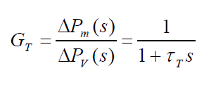
The turbine constant, T, is between 0.2 and 2.0 seconds where T.

2.11 FOR GOVERNOR: MATHEMATICAL MODELLING
Electrical power overrides mechanical power input when the electrical load is abruptly raised. As a result, the turbine's rotating energy is used to make up for the power shortage on the load side. As a result, the governor sends a signal to supply additional water, steam, or gas in order to increase the speed of the prime mover in order to make up for the speed shortage. This reduces the kinetic energy of the turbine, or the energy stored in the machine.
Figure 2.9: A graphic representation of the governor's speed restrictions
Speed restriction R is represented by the slope of the curve. Typically, governors have a 5-6% reduction in speed from no load to full load.
Or in s- domain
Through a hydraulic amplifier, the command PV is converted to the steam valve position command PG. The following s-domain relation results from assuming a linear relationship and taking into account the simple time constant g:
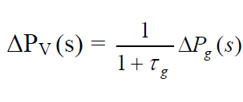
We obtain the following when we combine all the block diagrams from preceding block diagrams for a single are system
Figure 2.11: Block Mathematical Modelling Diagram of a single system that includes the Governor, Prime Mover, Generator, and Load

2.12 AUTOMATIC GENERATION CONTROL
When a system's load unexpectedly increases, the turbine speed decreases before the governor can adjust the steam input to the new load. The error signal gets less and the governor's position—rather than the position of the fly balls—gets closer to the point necessary to maintain the constant speed as the change in the speed value decreases. The addition of an integrator along the way is one method of returning the speed or frequency to its nominal value. The integrator unit will keep track of the average error over time and correct the offset. When a result, the generation is automatically changed to restore the frequency to the nominal value as the system load varies continually. Automatic generation control is the name given to this system. The AGC's job in a networked system with many pools is to distribute the load among the system's stations and generators in order to maximise efficiency and maintain a relatively consistent frequency.
2.13 AGC IN ONE LOCATION
When there is a change in the system load, the primary LFC loop with governor speed regulation may result in steady-state frequency variations. To reduce the frequency deviation to zero, we need to introduce an integral controller that operates on the load reference setting and modifies the speed set point. By increasing the system type by 1, the integral controller forces the final frequency fluctuation to zero. However, the gain of the integral controller must be adjusted to achieve an appropriate transient response.
Figure 2.12: AGC mathematical modelling for an isolated power system

The control system's closed loop transfer function is represented by:
2.14 AGC: MULTI AREA SYSTEMS
Many times, a collection of generators are internally strongly connected and swing together. Additionally, the reaction characteristics of the generating turbines frequently coincide. One refers to such a collection of generators as cohesive. The group is known as the control group and it is feasible to have the LFC loop represent the entire system. The true power delivered through the tie line for a two region system during normal operation is provided by
Considering a little change in the tie-line flow
consequently, the tie-line power deviation becomes the following shape.
Figure 2.13. Two area system with a central loop
LFC Particularly, the multivariable state vector system is the foundation of contemporary control design. We use the state variable parameters that can be gleaned from the system in our design procedure. A state estimator is created for systems when all of the state variables are not available. The feedback control can be implemented using a variety of methodologies:
2.15 POLE POSITIONING METHOD
Feedback of the state variables through a regulator with constant gains is used to establish control. Think of the system in the form of a state variable:
All of the roots of the system characteristic equation can be placed in the proper locations using the pole placement design, which eventually produces a regulator with a constant gain vector K.
Figure 2.14: Pole placement for control design
Consider the block diagram in Figure 11 above, which has the following state feedback control.
K is a vector of constant feedback gains with a length of 1n. It is assumed that the control system input r(t) is zero. When the states have been disrupted, the approach aims to reduce all of the state variable values to zero. Equation 9 is substituted for equation 7 to produce the representation of the compensated system state variables.
Equation for the corrected system characteristic
For the pole placement layout, the function [K, Af] = place pol (A, B, C, p) is designed. The device matrices are A, B, and C, and row matrix p includes the preferred closed-loop poles. The closed-loop matrix AF and the advantage matrix K are back with the aid of using the function. K= place (A, B, p), which makes use of a greater reliable algorithm, is used for a multi-enter device. The term "superior manage device" refers to a way used withinside the layout of manage structures that entails decreasing the overall performance index of the device variables. In this section, generally called the "linear quadratic regulator," we move over a way to assemble the fine controllers for linear structures with quadratic overall performance indices. Finding a manage rule u * (x, t) that may flow the device from its beginning country to its very last country with the aid of using decreasing the overall performance index is the aim of the most fulfilling regulator layout.
The quadratic overall performance index, that is primarily based total yet the minimum electricity criterion, is the overall performance index this is maximum often employed. Think about the plant we covered
Finding the control law's vector K is the issue.
which reduces the quadratic performance index J's value to its minimum value
Where Q is a actual symmetric matrix and R is a wonderful semidefinite matrix. If not one of the number one minors in Q are negative, then Q is a wonderful precise matrix.
The relative weighting of the numerous nation variables and manage inputs is made viable with the aid of using the choice of Q and R's elements. Using an n-vector of the unconstrained equation, we apply the Lagrange multiplier approach to derive the answer
By equating the partial derivative to zero, the optimal values are discovered.
Assuming that there exists a symmetric, time varying positive definite matrix p(t) satisfying
Substituting (20) in (18) we get
Obtaining the derivative of (20) we get
Finally, we equate (19) and (22)
The Riccati equation is the one presented above.
Typically, compensators are utilised in systems to meet all specified parameters. However, in the majority of circumstances, the system must also meet additional requirements that are challenging to meet with a compensated system. Instead of this, we primarily employ the Optimal Control system. The compensated design system's trial-and-error method makes it difficult for designers to meet requirements. This method of trial-and-error works best for systems with a single input and output. But for a system with several inputs and outputs, the trial-and-error approach is abandoned in favour of the Optimal Control design method, which eliminates trial-and-error uncertainties through parameter optimization. One overall performance index, particularly the indispensable rectangular overall performance index, makes up this device. In order to get better device overall performance for a hard and fast device configuration, the Lyapunov balance theorem is used to minimize the overall performance index. The values of Q and R need to be cautiously selected, and opportunity values of Q and R need to be selected if the responses are inappropriate. K is created automatically, and the closed loop replies are discovered.

2.16 PROBLEM STATEMENT
Consider an unreliable power system that develops from an N-interconnected system. Each unreliable system sample has the pair of equations shown below.
The matrices A, B, and C are considered to be fully observable, fully controlled, and of the proper dimensions. Equations 24 and 25 may also be expressed more succinctly as
The matrices A(t), B(t), and (t) that could alternate constantly over the years with inside the variety of parameter versions explicit imperfect understanding of the matrices A and B deterministically. Finding the manage characteristic U(t)=- KX(t), in which K is a steady advantage matrix, is the primary aim of interest. In this instance, the U(t) correctly finished the task. Therefore, identifying the manage matrix is just like identifying the steady advantage matrix K.
The balance resilience is much less at risk of parametric variant uncertainties with inside the LQR layout. The balance of the perturbed structures isn't always confident through LQR layout, primarily based totally the nominal structures. Take the linear unsure system, for example A(t) and B(t) are the related non-stop matrices that decide the levels of the uncertainty with inside the parameters, in which A(nn) and B(nm) are the nominal parameter matrices. The circumstance in (27) is stated to be met, presuming that A and B are completely observable and controllable, if non-stop time matrix capabilities G(r(t)) and H(s(t)) exist such that:
The matrices G and H are, respectively, continuous functions of r(t) and s(t) and continuous time-variant matrices. They are the ambiguous parameters that are thought to be constrained by the circumstances:
The primary objective, as previously described, is to construct a control input of the type U(t)= -KX(t), where K belongs to Rmn so that the law stabilises the matched uncertain system in (27). Take into account the system in (27) that meets the matching requirements in (28) and (29). There exists an optimal * >0 such that any values of that are bigger than or equal to * have a positive definite solution to the following equation. Let Q(nm) be any positive-definite symmetric matrix.
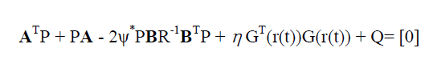
The machine is taken into consideration to be linear, and the uncertainties are minimized. Therefore, A(t)=zero and B(t)=zero as a result, equation 32 is decreased to the ricarti equation, A T P + PA - 2* PBR -1B T P + Q= [0].

2.17 TWO AREA CREATING A POWER SYSTEM MODEL
Consider an i-th area power system. We then write the differential equation regulating the system's functioning under normal circumstances, assuming that there are no disturbances. Governor Differential Equation:
33Tie Line Power Equation:

2.18 SUMMARY
In this chapter modelling of power system, advantages of inter connection, mathematical modelling of governor, generator, load, and reasons for frequency limits, multi area system and problem statement are discussed.

CHAPTER 3
MODELING OF TWO AREA INTERCONNECTED POWER SYSTEM BY USING PID WITH PSO ALGORITHM AND FUZZY LOGIC CONTROLLER
3.1 INTRODUCTION
Based on the many features that can be applied when employing a fuzzy logic controller, the Mamdani approach was chosen for this investigation. Complex non-linear systems are managed using fuzzy logic rather than mathematical analysis. Furthermore, this method enables the addition or removal of particular member functions and rule bases without having to start from scratch in the event that the way power systems are employed changes. It may be simpler to employ conventional methods and fuzzy logic applications together. Regardless of variations in demand, automatic production control is in charge of controlling frequency and power flow in interconnected systems. Area control error (ACE), frequency, and link power—a linear mixture of power mismatch and frequency deviations—are the reference parameters used to calculate the link line. There are ways to make a power system model that is more realistic by taking into account physical restrictions such the maximum production speed of thermal turbines, the dead band of the speed regulator, and time delay.
There are methods for creating a more literary power system model that account for physical constraints such the thermal turbines' production speed limit, the speed regulator's dead band, and the time delay. Some research plans a four-zone interconnected power system with control dead bands and production rate limitations. However, there are just two inputs to the controller in this investigation. Figure 7 shows that the first input that serves as the variable ACE is the area control error and that the second input that serves as the variable ACE is the change in the area control error. The output (Freq-Level), as seen in Figure 9, displays the degree of frequency change brought on by an increase or decrease in load. The basic architecture of the fuzzy controller requires three phases, as shown in Figure 6.

3.2 PID CONTROLLER

A PID controller is a device utilized in commercial manipulates programs to alter temperature, flow, pressure, velocity and different technique variables. PID (proportional essential derivative) controllers use a manipulated loop comments mechanism to manipulate technique variables and are the maximum correct and solid controller. The sub system of the proportional derivative integral control as shown above. this consists of three main blocks those are proportional block, integral block, and derivative block. These three blocks are connected to the one common summing point.
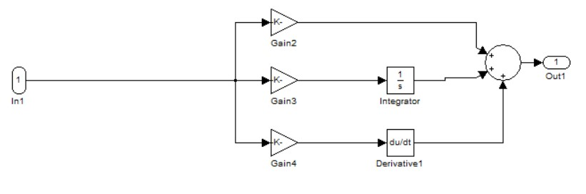
Figure 3.1 Pid controller circuit diagram
Table 3.1 : for PID controller
Kp | 0.99999
Ki | 0.899
Kd | 0.7888

3.3 PSO PARTICAL SWARM OPRIMIZATION
Kennedy and Eberhart are credited with developing the optimisation technique known as particle swarm optimisation (PSO). It was created using simulations and has successfully handled issues with continuous nonlinear optimisation. When compared to other stochastic approaches, PSO is renowned for its capacity to deliver high-quality solutions with a consistent convergence characteristic in a brief period of time. A stochastic optimisation technique called PSO uses a population-based strategy. A swarm of particles, also known as people, is created during the process, and each one of them stands for a potential answer to the optimisation problem.
Each particle uses the PSO approach to move around a multidimensional search space, constantly modifying its position based on its own and its nearby particles' experiences. The swarm can then explore the search space and move closer to the ideal answer to the optimisation problem. In PSO, a particle moves towards an ideal solution by using both its own best position thus far and the best positions of the particles nearby. By using this strategy, particles can travel towards a minimum while still scouting a large area around the ideal solution. Each particle's performance is assessed using a fitness function that has been pre-defined and captures the essential elements of the optimisation problem. This gives the algorithm a way to assess how well a particle is doing with respect to the issue it is attempting to address.
3.3.1 Steps for PSO Algorithm
Step 1: To carry out optimization using PSO, various control parameters must be set. These parameters include the population size, acceleration constants (C1, C2), convergence criterion, number of problem variables, and lower and upper bounds of variables. Additionally, the maximum number of iterations is also specified as a control parameter for the PSO optimization process. Once the control parameters are set, the PSO optimization process begins by creating a population of starting particles. These particles are randomly assigned positions and velocities. The optimization process then continues iteratively, with each particle adjusting its position and velocity based on its own experience and that of its neighbours. This continues until a satisfactory solution is found, or the maximum number of iterations is reached. The positions and velocity of initial swarm of the particle are randomly generated using lower and upper bounds of design variables. For ith particle position and velocity are generated as follows
x_{i}^{t+1}=x_{i}^{t}+v_{i}^{t}*t
X₀^{i} = X_{min} + (X_{max} - X_{min}) * rand
V₀^{i} = V_{min} + (V_{max -} V_{min}) * rand
Step 2: For each particle calculate the value of fitness function.
Step 3: Each particle's fitness is evaluated in the PSO optimisation process against its personal best position (pbest). If the current solution is more fit than the pbest, the current fitness is used instead. Additionally, the global best position (gbest) is used to compare each particle's fitness. The position of any particle whose suitability exceeds that of the gbest is substituted in its stead. This guarantees that the particles communicate with one another and continuously seek out the optimum option to enhance the efficiency of the optimisation process as a whole.
Step 4: Update the velocity and positions of all particles. The velocity of ith particle is updated as
V^{i}_{k+1} =V_{k}^{i} + c1 * r1(p^{i}_{bestk} - X^{i}_{k}) + c2 * r2 (G_{best} - X^{i}_{k})
Where V_{k}^{i} is the velocity of ith particle at time k.c1,c2 are acceleration constants.r1,r2 are random variables. P^{i}_{bestk} is the personal best position of ith particle at time k. G_{best} is the global best position of ith particle. X^{i}_{k} is the position of ith particle at time k. The position of the particle is updated as
X^{i}_{k+1} = X^{i}_{k} + V^{i}_{k+1}
Step-5: Repeat the steps from 2 to 4 until the desired fitness is reached.
For i=1,2,3.......n.
m = 1,2,3.....d.
where,
n:- Number of particles in the group.
d:- dimension index.
t:- Pointer of iteration.
Vi,m ^{(t)} :- Velocity of particle at iteration i.
W:- Inertia weight factor.
C1 , C2 :- Acceleration Constant.
rand() :- Random number between 0 and 1.
Xi,d ^{(t)} :- Current position of the particle ‘i’ at iteration.
Pbest_{i}:- Best previous position of the ith particle.
Gbest:- Best particle among all the particle in the swarming population.

3.3.2 Flow chart
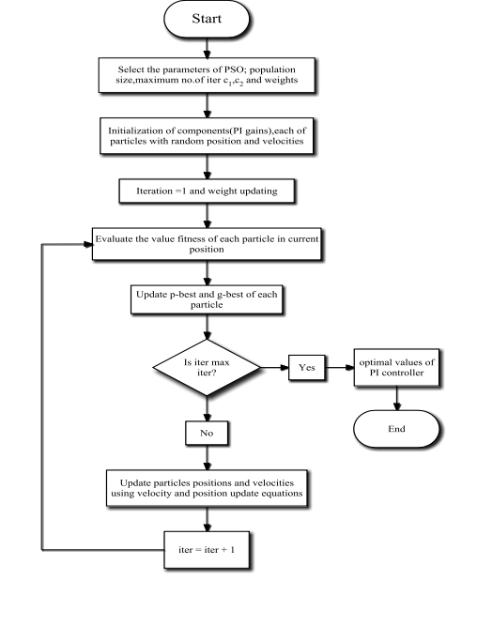
Figure 3.2: Flow Chart of Particle Swarm Optimization

3.3.3 EVALUATION OF FITNESS FUNCTION
The objective function in this situation is performance indices, and the fitness function is based on an error criteria. The integral square error (ISE), integral absolute error (IAE), and integral time multiplied by absolute error (ITAE) are used to evaluate the performance of the controller. The minimum performance index value is used to adjust the PID controller.
I_{ITAE} = ∫₀^{T} t|e(t)| * dt

3.4 PROBLEM STATEMENT
The project aim is to design a PID controller for decreasing damping oscillations in terms of
Rise time, Settling time, overshoot, Peak, Peak time
Let us consider for example
Plant transfer function is
T(s) = (25.2*S2 +21.2*S +3)/(S5 + 16.58*S4 + 25.41*S3 +17.18*S2 +11.70*S+1)
For the plant model the transfer function is as follows: -
T1=([25.2 21.2 3],[1 16.58 25.41 17.18 11.70 1])
The parameters can be obtained as follows: -
S=Stepinfo{T1,’RiseTimelimits’,[0.1, 0.9]}
The above command returns: -
S=
Rise Time : 0.821 sec
Settling Time : 18.5 sec
Overshoot : 52.1%
Peak : 1.14
Peak Time : 2.19 sec
In this problem, it is observed, the rise time, settling time, overshoot, peak, peak time

3.4.1 BLOCK DIAGRAM
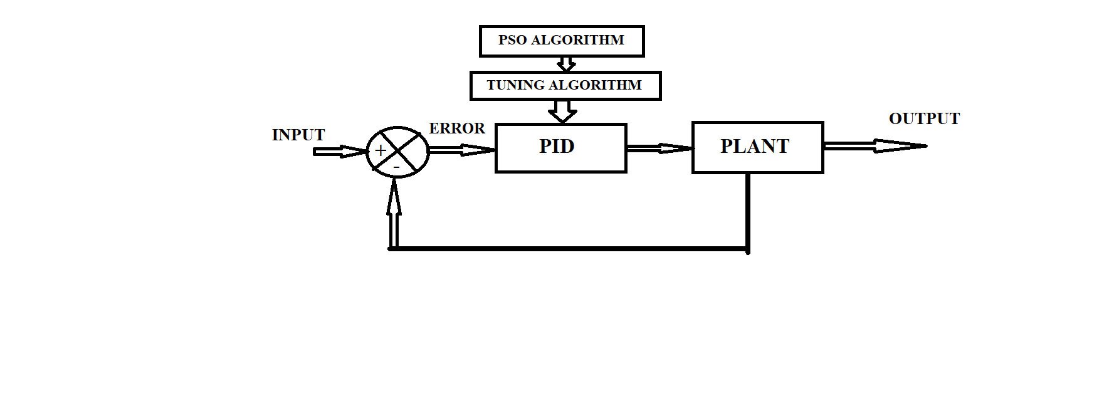
3.4.2 APPLICATION OF PSO TO THE PLANT
clc;
clear all;
close all;
ns=[25.2 21.2 3];
ds=[1 16.58 25.41 17.18 11.70 1];
G=tf(ns,ds);
Gf=feedback(G,1);
step(Gf)
hold on
%PSO Constant Parameters
c=1.5;w=0.5;particles=100;iteration=1000;Var=3;
%Search Space Best Performance
a=0; %lower bound
b=5; %upper bound
%Optimization Steps
c_cf=0;
%Intialization
for m=1:particles
for n=1:Var
v(m,n)=0; %Velocity Particles
x(m,n)=a+rand*(b-a); %Position Particles
xp(m,n)=x(m,n);
end
%Model Parameters
kp=x(m,1);
ki=x(m,2);
kd=x(m,3);
%Simulation Model
Gc=pid(kp,ki,kd);
Gcf=feedback(Gc*G,1);
y=step(Gcf);
%ITAE (Objective Function)
ff1=0;
sim1=size(y);
for m1=1:sim1;
ff1=ff1+((abs(y(m1)-1))*m1);
end
ITAE(m)=ff1;
End
%Find the Best Value
[Best_Performance,location]=min(ITAE);
fg=Best_Performance
xg(1)=x(location,1)
xg(2)=x(location,2)
xg(3)=x(location,3)
for i=1:iteration %No of repetiton
for m=1:particles %No of Particles
for n=1:Var %No of Var
v(m,n)=(w*v(m,n))+(c*rand*(xp(m,n)- x(m,n)))+(c*rand*(xg(n)-x(m,n))); %Update Velocity
x(m,n)=x(m,n)+v(m,n); %Update Position
end
%Check Bound
for n=1:Var
if x (m,n)<a
x(m,n)=a
end
if x(m,n)>b x(m,n)=b;
end
end
%Model Parameters
kp=x(m,1);
ki=x(m,2);
kd=x(m,3);
%Simulation Model
Gc=pid(kp,ki,kd);
Gcf=feedback(Gc*G,1);
y=step(Gcf);
%ITAE (Objective Function)
ff1=0;
sim1=size(y);
for m1=1:sim1;
ff1=ff1+((abs(y(m1)-1))*m1);
end
ITAEp(m)=ff1;
%Compare Local
if ITAEp(m)<ITAE(m)
ITAE(m)=ITAEp(m);
xp(m,1)=x(m,1);
xp(m,2)=x(m,2);
xp(m,3)=x(m,3);
end
end
%Compare Global
if B_fg<fg
fg=B_fg; %New Global Value
xg(1)=xp(location,1); %Position of Var1
xg(2)=xp(location,2); %Position of Var2
xg(3)=xp(location,3); %Position of Var3
end
c_cf=c_cf+1;
best_cf_ac(c_cf)=fg;
end
Min_ITAE=fg
kp=xg(1)
ki=xg(2)
kd=xg(3)
Gc=pid(kp,ki,kd);
Gcf=feedback(Gc*G,1);
step(Gcf);
t_cf=1:c_cf;
Figure
plot(t_cf,best_cf_ac,'r--','LineWidth',2),
xlabel('Iteration’),
ylabel('CostFunction(ITAE)’)
legend('ITAE for PSO-PID’)
title('ITAE with each iteration’)

3.4.3 PSO WITHOUT CONTROLLER
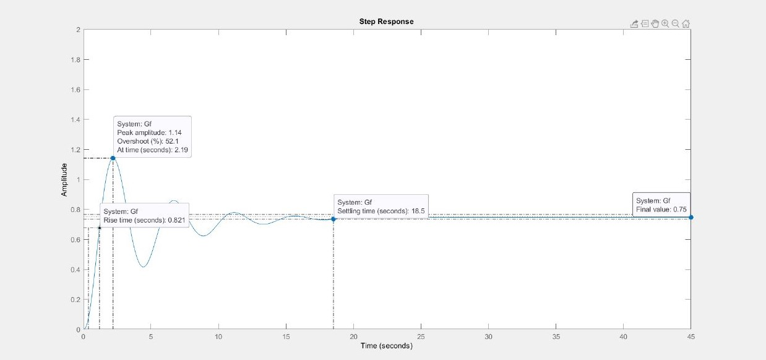
Figure 3.3: - Step Response without controller
3.4.4 THE PROGRAM FOR THE SIMULATION PLOT
This program is to obtain the step response of various optimized systems with optimal [KD KP KI] values
Clc
close all
kd=input('enter the value of kd');
kp=input('enter the value of kp');
ki=input('enter the value of ki');
T1=tf([25.2*kd 21.2*kd+25.2*kp 25.2*ki+21.2*kp+3*kd 21.2*ki+3*KP 3*ki],[1 16.58 25.41+25.2*kd 17.18+21.2*kd+25.2*kp 11.70+25.2*ki+21.2*kp+3*kd 21.2*ki+3*kp+1 3*ki]);
Ltiview

3.4.5 PSO BASED SIMULATION AND RESULTS
Fitness function of the open loop transfer function of the raw plant:
T(s) = (25.2*S2 + 21.2*S +3)/(S5 +16.58*S4 +25.41*S3 +17.18*S2 +11.70*S+1)
F(Raw Plant) = 22.3066
We have adjusted the number of iterations in our simulations using the PSO algorithm while maintaining the swarm's population at 200.In this study, we compare the performance of the initial global best position obtained from a swarm of randomly initialised particles to the performance of the final global best position obtained via the use of the "particle swarm optimisation" algorithm.
The result in the tabular format:
Number of Iterations | Optimal Best Fitness Function | Optimal Best Point
100 | 39.9511 | 4.0801 1.3359 0.8244
200 | 34.5952 | 4.5371 1.4322 0.9588
300 | 30.1938 | 4.1154 1.3341 1.0210
400 | 29.0453 | 4.2512 1.3629 1.0587
500 | 28.9909 | 4.2514 1.3628 1.0617
600 | 28.2507 | 4.3920 1.3931 1.0891
700 | 28.2153 | 4.3923 1.3930 1.0907
800 | 28.2153 | 4.3923 1.3930 1.0907
900 | 28.2044 | 4.4046 1.3958 1.0907
1000 | 28.1846 | 4.4047 1.3958 1.0919

No of iteration:1000;
Best fitness:28.1846;
Optimal best point: 4.4047 1.3958 1.0919

3.4.6 SIMULATION RESULTS WITH DIFFERENT ITERATIONS
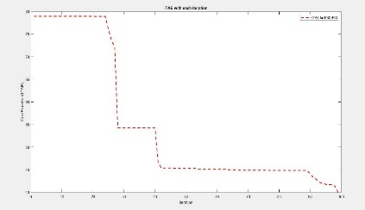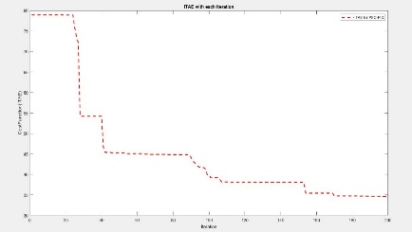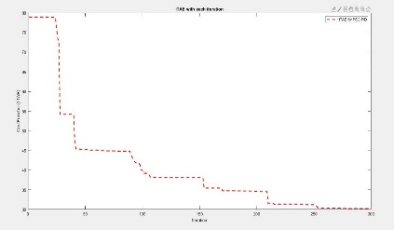
100 200 300
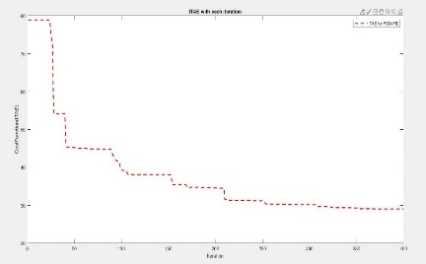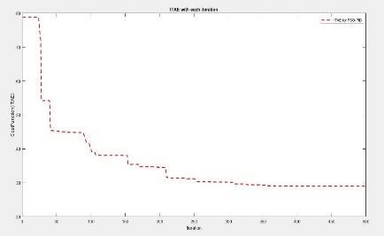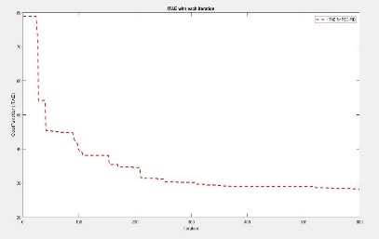
400 500 600
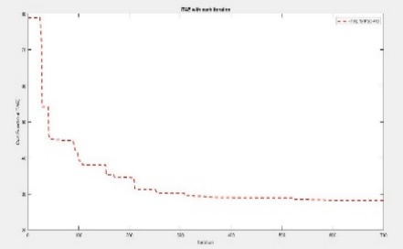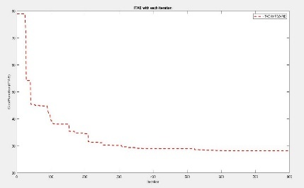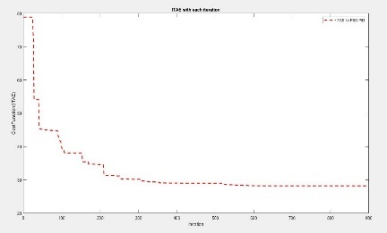
700 800 900
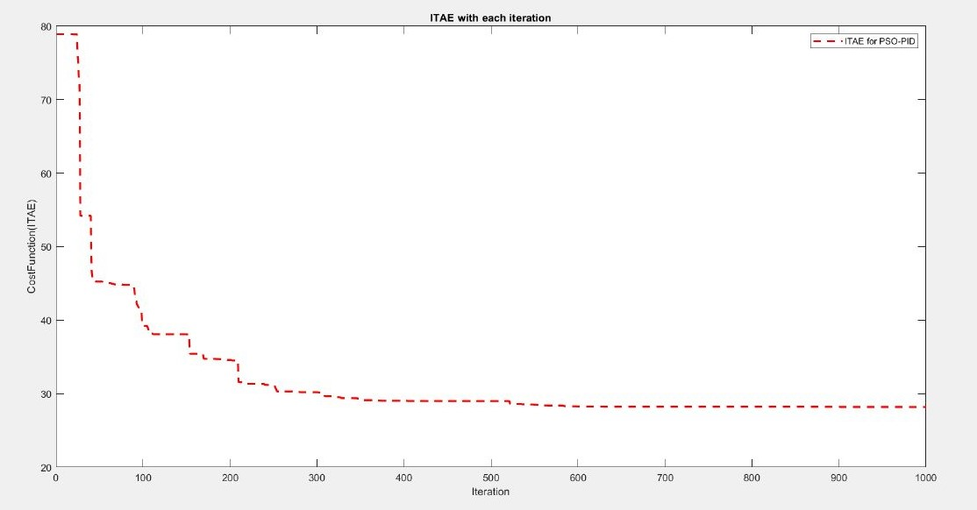
The final 1000 iterations result of PSO.

3.4.7 PSO with controller
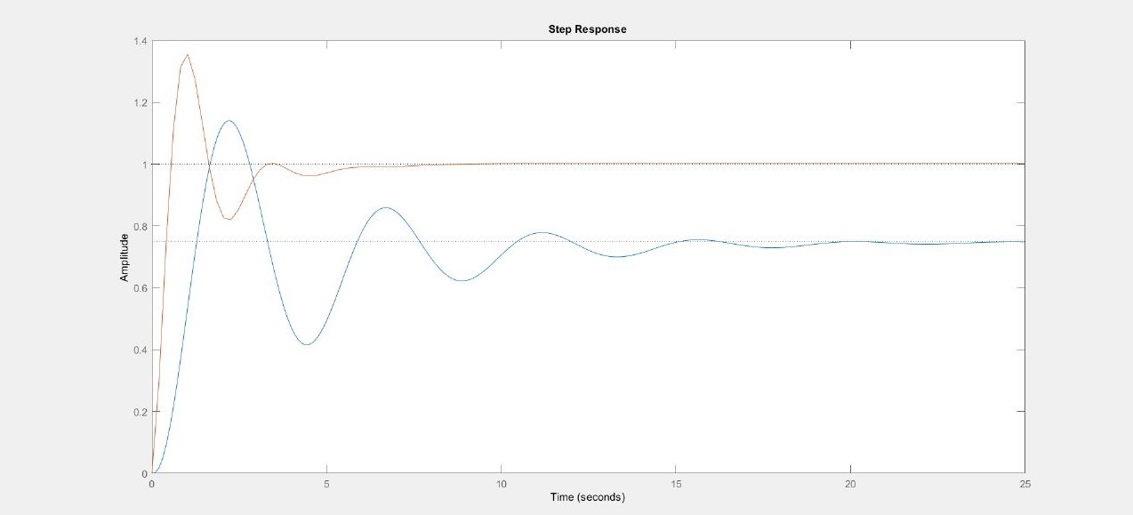
Figure 3.4: - Step Response with controller for 1000 Iterations

3.5 MODELLING OF FUZZY
Figure 3.5: Main steps of fuzzy control
By allocating a single fuzzy set, a set with membership function (A), and a zero in another place, the input variables are identified. If the output variable is a fuzzy set, the intended control action is expressed by the maximum min and fuzzy relation with the composition. By blurring, the fuzzy set of the output variable is solved, and the centroid method is used to produce a precise numerical value. Equation 8 illustrates the fuzzy rule base as a collection of forms based on the IF-THEN fuzzy base rule principle. Where x1, x2,... xn U and y1 R are the inputs and outputs of the fuzzy sets in U1, U2, and R, which represent the kth antecedent pair and conclusion pair, respectively. The numbers of the rules are Ui, Ri, and n, and Fk = U1 U 2. In Table 1, which reflects all of the rule bases of the proposed method, the range from -1 to 1 is divided into seven-member functions in order to increase the stability and accuracy of the fuzzy controller.
Figure 3.6: The Area control error for the first input
Figure 3.7: The change area in area control error (ACE) for the second input

Table 3.2 : rules for fuzzy logic controller
Figure 3.8: The change in frequency level for output

Table 3.3: Rules of fuzzy logic controller
The fuzzy logic controller has the following 49 rules. The explanation of the rules as follows
- ACE is ( HN) and ∆ACE is (HN) then change in frequency is ( HP)
- ACE is ( HN) and ∆ACE is (MN) then change in frequency is ( HP)
- ACE is ( HN) and ∆ACE is (LN) then change in frequency is ( HP)
- ACE is ( HN) and ∆ACE is (Z) then change in frequency is ( MP)
- ACE is ( HN) and ∆ACE is (LP) then change in frequency is ( MP)
- ACE is ( HN) and ∆ACE is (MP) then change in frequency is (LP)
- ACE is ( HN) and ∆ACE is (HP) then change in frequency is ( Z)
- ACE is ( MN) and ∆ACE is (HN) then change in frequency is ( HP)
- ACE is ( MN) and ∆ACE is (MN) then change in frequency is ( MP)
- ACE is ( MN) and ∆ACE is (LN) then change in frequency is ( MP)
- ACE is ( MN) and ∆ACE is (Z) then change in frequency is ( MP)
- ACE is ( MN) and ∆ACE is (LP) then change in frequency is ( LP)
- ACE is ( MN) and ∆ACE is (MP) then change in frequency is ( Z)
- ACE is ( MN) and ∆ACE is (HP) then change in frequency is ( LN)
- ACE is ( LN) and ∆ACE is (HN) then change in frequency is ( HP)
- ACE is ( LN) and ∆ACE is (MN) then change in frequency is ( MP)
- ACE is ( LN) and ∆ACE is (LN) then change in frequency is ( LP)
- ACE is ( LN) and ∆ACE is (Z) then change in frequency is ( LP)
- ACE is ( LN) and ∆ACE is (LP) then change in frequency is ( Z)
- ACE is ( LN) and ∆ACE is (MP) then change in frequency is ( LN)
- ACE is ( LN) and ∆ACE is (HP) then change in frequency is ( MN)
- ACE is ( Z) and ∆ACE is (HN) then change in frequency is ( MP)
- ACE is ( Z) and ∆ACE is (MN) then change in frequency is ( MP)
- ACE is ( Z) and ∆ACE is (LN) then change in frequency is ( LP)
- ACE is ( Z) and ∆ACE is (Z) then change in frequency is ( Z)
- ACE is ( Z) and ∆ACE is (LP) then change in frequency is ( LN)
- ACE is ( Z) and ∆ACE is (MP) then change in frequency is ( MN)
- ACE is ( Z) and ∆ACE is (HP) then change in frequency is ( MN)
- ACE is ( LP) and ∆ACE is (HN) then change in frequency is ( HP)
- ACE is ( LP) and ∆ACE is (MN) then change in frequency is ( LP)
- ACE is ( LP) and ∆ACE is (LN) then change in frequency is ( Z)
- ACE is ( LP) and ∆ACE is (Z) then change in frequency is ( LN)
- ACE is ( LP) and ∆ACE is (LP) then change in frequency is ( LN)
- ACE is ( LP) and ∆ACE is (MP) then change in frequency is ( MN)
- ACE is ( LP) and ∆ACE is (HP) then change in frequency is ( HN)
- ACE is ( MP) and ∆ACE is (HN) then change in frequency is ( LP)
- ACE is ( MP) and ∆ACE is (MN) then change in frequency is ( Z)
- ACE is ( MP) and ∆ACE is (LN) then change in frequency is ( LN)
- ACE is ( MP) and ∆ACE is (Z) then change in frequency is ( MN)
- ACE is ( MP) and ∆ACE is (LP) then change in frequency is ( MN)
- ACE is ( MP) and ∆ACE is (MP) then change in frequency is ( MN)
- ACE is ( MP) and ∆ACE is (HP) then change in frequency is ( HN)
- ACE is ( HP) and ∆ACE is (HN) then change in frequency is ( Z)
- ACE is ( HP) and ∆ACE is (MN) then change in frequency is ( LN)
- ACE is ( HP) and ∆ACE is (LN) then change in frequency is ( MN)
- ACE is ( HP) and ∆ACE is (Z) then change in frequency is ( MN)
- ACE is ( HP) and ∆ACE is (LP) then change in frequency is ( HN)
- ACE is ( HP) and ∆ACE is (MP) then change in frequency is ( HN)
- ACE is ( HP) and ∆ACE is (HP) then change in frequency is ( HN)

Where;
HN: High negative
MN: Medium negative
LN: Low negative
Z: Zero
LP: Low positive
MP: Medium positive
HP: Medium positive
ACE: Area control error
∆ACE: Change in area control error

3.6 MATHEMATICAL CALCULATION FOR THE TWO AREA WITH OUT LOAD CONTROLLER
Table 3.4: parameters of two area lfc Area 1 Area 2
Speed regulation | R1 = 0.05 | R2 = 0.0625
frequency sensor load coefficient | D1 =0.6 | D2=0.9
Inertia constant | H1=5 | H2=4
Base power | 1000 MVA | 1000 MVA
Governor time constant | Tg1 =0.2 sec | Tg2 = 0.3 sec
Turbine time constant | Tt1 = 0.5 sec | Tt2 = 0.6 sec

The per unit load change in area 1 is ∆PL1 = 187.5 ÷ 1000 = 0.1875 pu
The per unit steady state frequency deviation is ∆ $ω$ss = -∆PL1 ÷ ( 1/R1+D1) +( 1/R2+D2)
∆ $ω$ss = -0.1875 ÷ ( 20 +0.6 ) +( 16 + 0.9) = -0.005 pu
The steady state frequency deviation in Hz is ∆f = ( -0.005 ) × 50 = -0.25Hz
The new frequency is (f) =f0 + ∆f
F = 50 -0.25 = 49.75
Change in mechanical power in area1 ∆ Pm1 = - ∆ $ω$÷ R1
∆Pm1 = -0.005 ÷ 0.05 = 0.10 pu
Change in mechanical power in area2 ∆Pm2 = - ∆ $ω$÷ R2
∆Pm2 = -0.005 ÷ 0.0625 = 0.080 pu
Change in area 1 load is ∆D1$ω$ = ∆×$ω$ D1
∆$ω$D1 = (-0.005)× 0.6 = -0. 003 pu = -0.3 MW
Change in area 2 load is ∆$ω$D2 = ∆× $ω$D2
∆$ω$D2 = ( -0.005 ) × 0.9 = -0.0045 pu = -4.5 MW
Change in total area load is = -7.5 MW
Tie- line power flow ∆P12 = ∆$ω$ × ( 1/R2+D2)
∆P12 = -0.005 × 16.9 = -0.0845 pu

3.7 TWO AREA LOAD FREQUENCY CONTROL
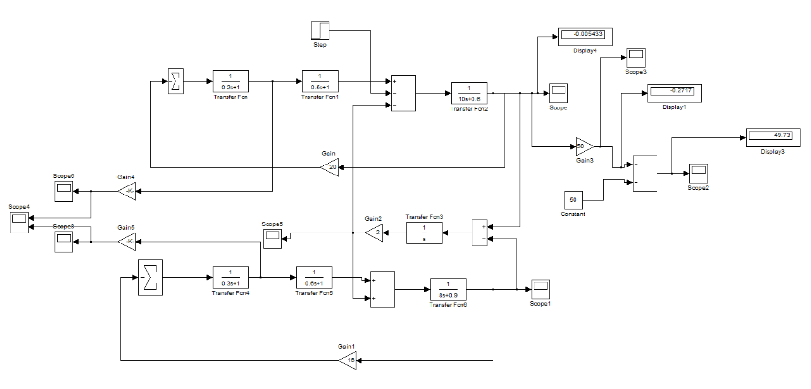
Figure 3.9: Circuit dig of two area load frequency control
In the circuit diagram of two area load frequency control we have three main blocks governor, turbine, load. we can connect the two areas with the tile line to measure the change in frequency. In this diagram we connect two areas without any controller and measure the steady state frequency and change in frequency that is new frequency and the tie line power flow in the circuit and change in area 1 load and change in area 2 load and the total area load. Here mainly we calculate the steady state frequency deviation two area interconnected power system.
3.8 CASE .1
1.1 The input load is 0.2 MW at the two area modeling of LFC using PID using PSO Controller.

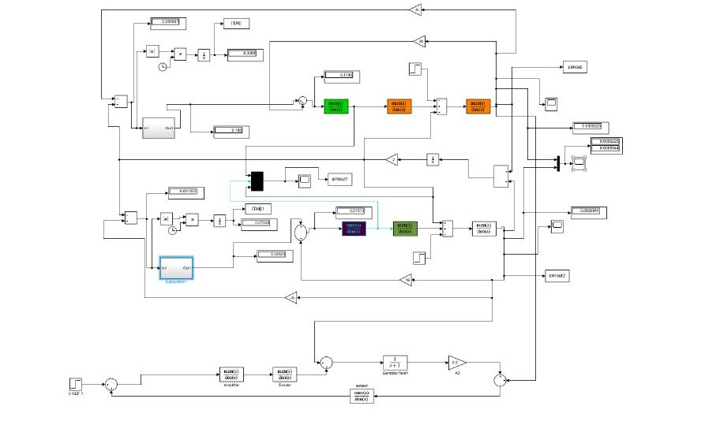
Figure 3.10: two area load frequency with PID using PSO controller
According to the case 1 two area load frequency with pid using pso controller in this case the first area is connected with the pid using pso controller and the load is increased by 0.2 pu and the second area is also connected with the pid using pso controller and the load is increased by 0.2 pu with the same parameters, and observe how much the frequency is changing. In this case and compared to fuzzy logic controller the change in frequency of pid using pso controller is low.
1.2 The input load is 0.2 mw at the two area modeling of lfc using fuzz logic controller.

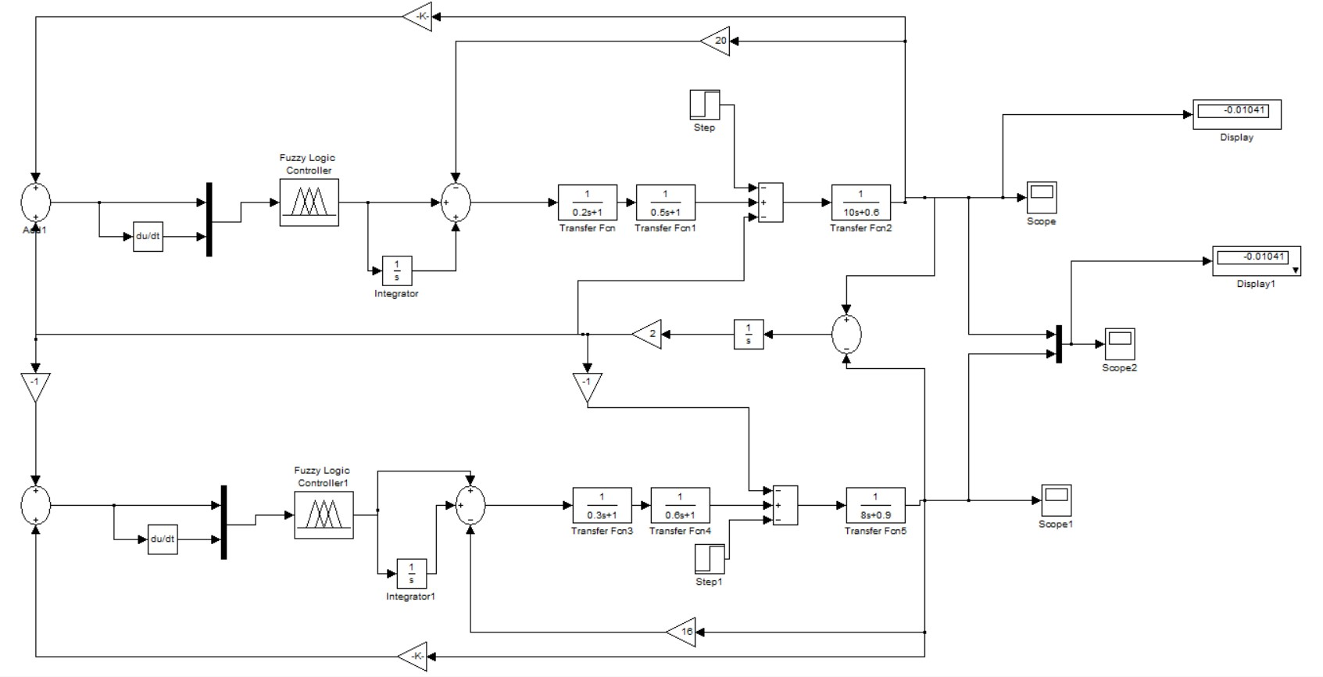
Figure 3.11: two area load frequency with fuzzy logic controller
According to the case 1 two area load frequency with fuzzy logic controller in this case the first area is connected with the fuzzy logic controller and the load is increased by 0.2 pu and the second area is also connected with the fuzzy logic controller and the load is increased by 0.2 pu with the same parameters, and observe how much the frequency is changing. In this case compared to pso using pid controller the steady state change in frequency of fuzzy logic controller is high.

3.9 CASE 2 :
2.1 The input load is 0.2 mw at the first area modeling of lfc with using pid using pso controller.

Figure 3.12: two area load frequency with PID using PSO controller
According to the case 2 two area load frequency with pid using pso controller in this case the first area is connected with the pid using pso controller and the load is increased by 0.2 pu and the second area is also connected with the pid using pso controller and the load is zero with the same parameters, and observe how much the frequency is changing. In this case and compared to fuzzy logic controller the change in frequency of pid using pso controller is high.

2.2 The input load is 0.2 mw at the first area modeling of lfc using fuzzy logic controller.
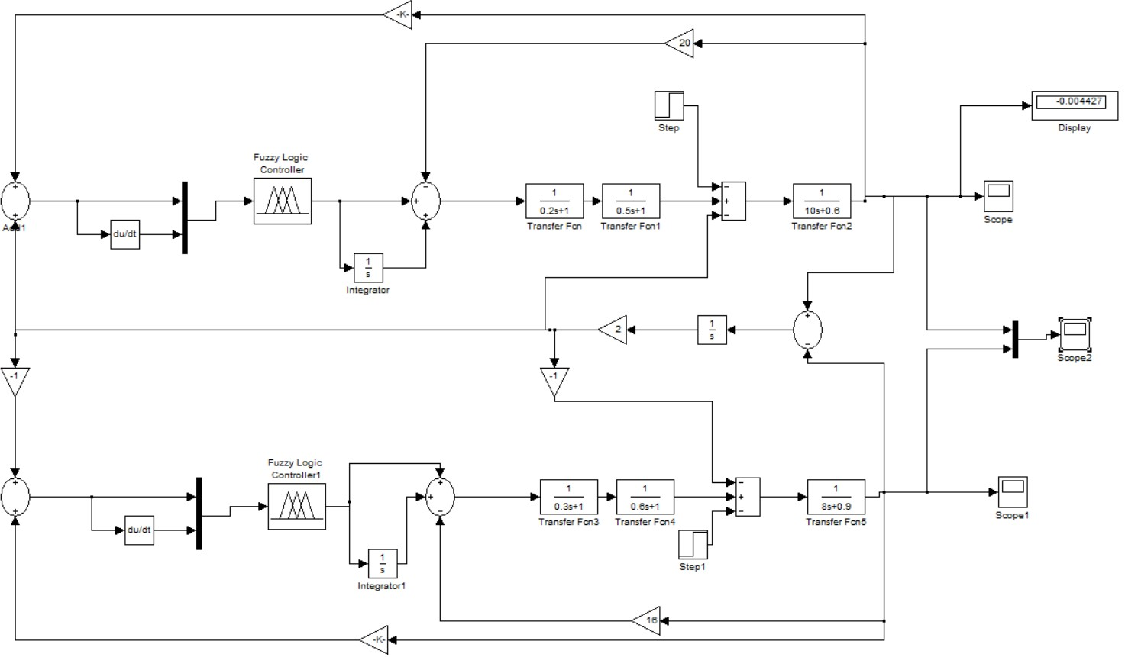Figure 3.13: two area load frequency with fuzzy logic controller
According to the case 2 two area load frequency with fuzzy logic controller in this case the first area is connected with the fuzzy logic controller and the load is increased by 0.2 pu and the second area is also connected with the fuzzy logic controller and the load is zero with the same parameters, and observe how much the frequency is changing. In this case and compared to pid using pso controller the steady state change in frequency of fuzzy logic controller is high.

3.10 CASE 3 :
3.1 The input load is 0.2 mw at the first area modeling of lfc using pid using pso & fuzzy controller.

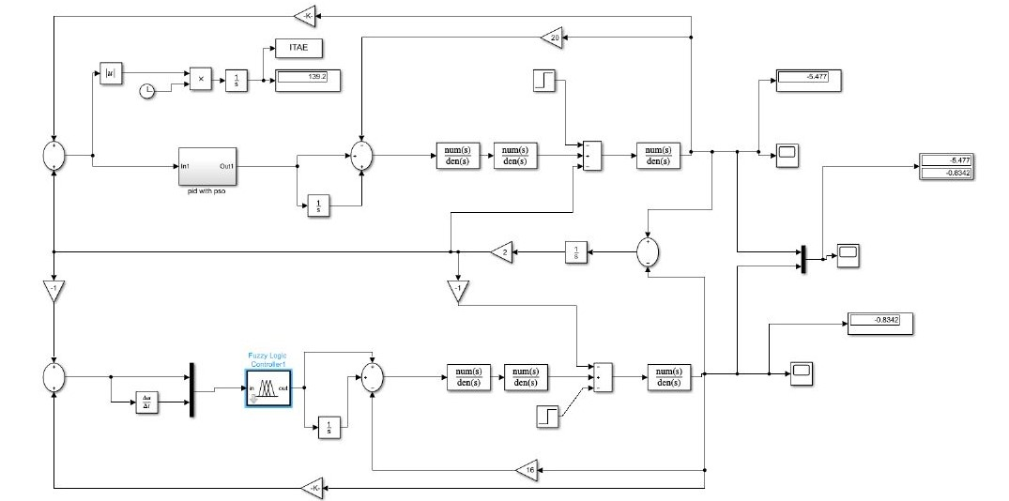
Figure 3.14: load frequency control with using pid using pso and fuzzy controller
According to case 3 the response of load frequency control to a load change in an interconnected two areas power system with the same parameters the load is increased by 0.2 at the first area and the first area is controlled by pid using pso controller. The second area is controlled by fuzzy logic controller and the load for the second area is zero in this case and observe the steady state frequency change in each area.

3.11 CASE 4:
4.1 the input load is 0.2 mw at the two area modelling of lfc using pid using pso & fuzzy controller
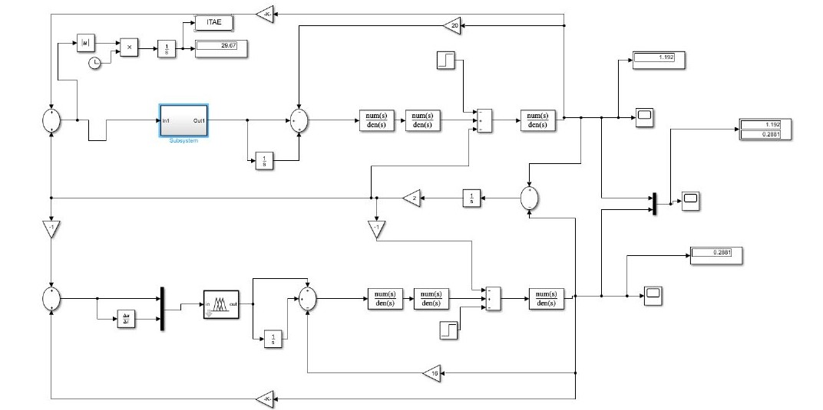
Figure 3.15: load frequency control with using pid using pso and fuzzy controller
According to case 3 the response of load frequency control to a load change in an interconnected two areas power system with the same parameters the load is increased by 0.2 at the first area and the first area is controlled by pid using pso controller. the second area is controlled by fuzzy logic controller and the load for the second area is increased by 0.2 and observe the steady state frequency change in each area. Compared to pid using pso controller the steady state frequency deviation in fuzzy logic controller is very high.

3.12 DESIGN OF FUZZY LOGIC CONTROLLER

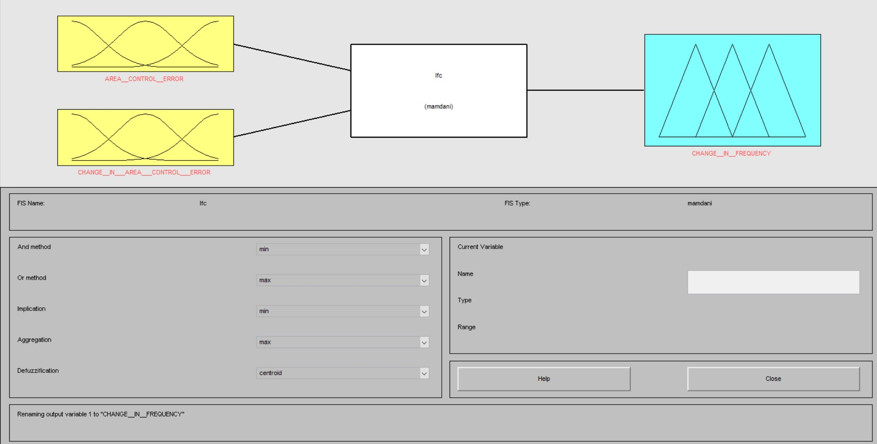
Figure 3.16: Fuzzy logic design in matlab
This is the simulation circuit design of a fuzzy logic controller. We have two types of fuzzy logic designs those are mamdani and sugeno type. the mostly used design type is mamdani type in this circuit we use mamdani type fuzzy logic controller. There are two inputs and one output for fuzzy logic controller. the first input we take as area control error and the second input we take as change in area control error, and the output is change in frequency.

3.13 RULES FORMATION FOR FUZZY LOGIC
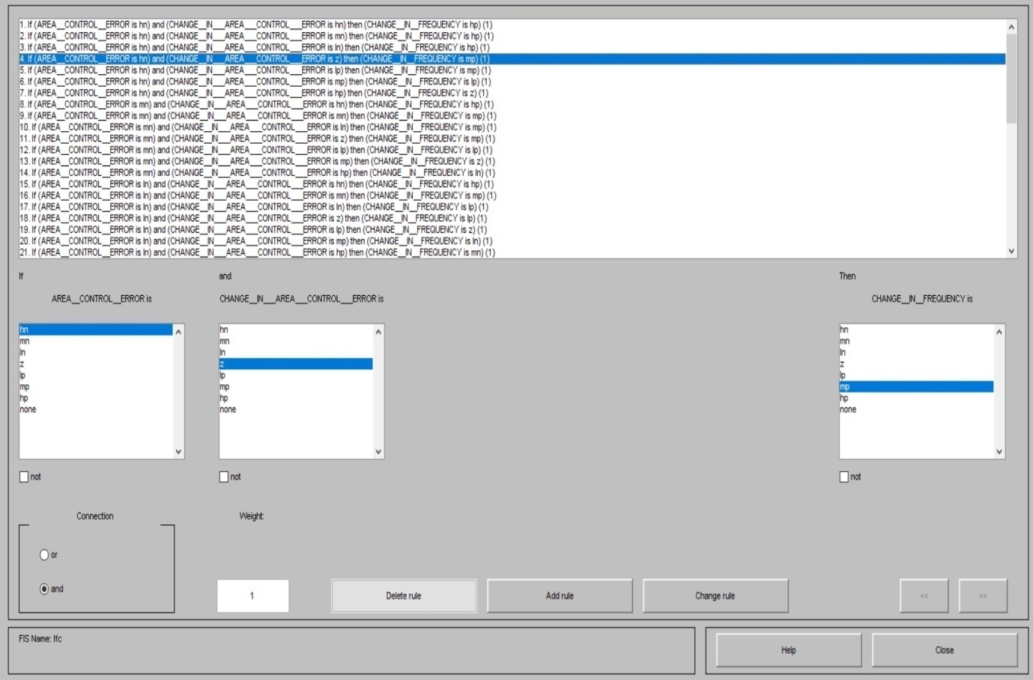
Figure 3.17: Rules for fuzzy logic controller
This is the formation of rules for a fuzzy logic controller in a simulation here we have a 49 rules. each rule changes the effect of the output. in the fuzzy logic controller we have two connections AND and OR connections. in this we are using AND connection. if we take the high negative as area control error and the change in area control error is high negative like that we are applying the 49 rules the explanation of the rules is mentioned above.

3.14 SUMMERY
In this chapter modelling of two area interconnected power system using fuzzy logic and Pid using pso algorithm, modelling of fuzzy and modelling of Pid using pso, and four case studies for pid using pso and fuzzy logic controller of two area interconnected power system is discussed.

CHAPTER 4
SIMULATION RESULTS AND DISCUSSION
4.1 INTRODUCTION
This article essentially presents a comparison by using PID with PSO algorithm and fuzzy controllers in four distinct circumstances. As will be demonstrated in several simulated scenarios, the comparison of PID with PSO algorithm and fuzzy controller will be among the most crucial elements from which we may choose the optimum controller, including change in frequency, integral time multiplied by absolute error (ITAE) and steady state error (SSE). We will also use the FIS toolbox and Simulink in MATLAB to solve the following numerical example so that we can differentiate between the controllers.

4.2 TWO AREA LOAD FREQUENCY CONTROL
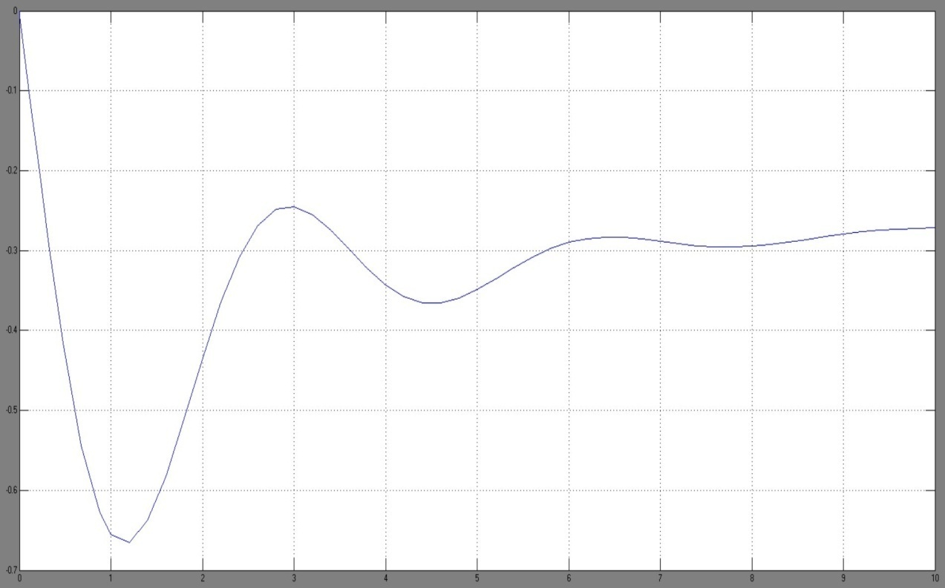
Figure 4.1: for steady state change in frequency in per unit

This is the graph for two area load frequency control without any controller here the graph shows the steady state change in frequency.

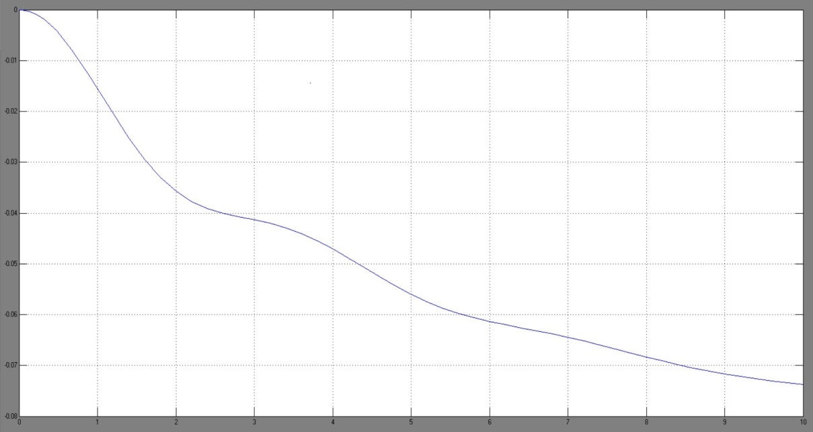
Figure 4.2: for Tie- line power
This graph shows the tie line power control of two area without any pid and fuzzy logic controller
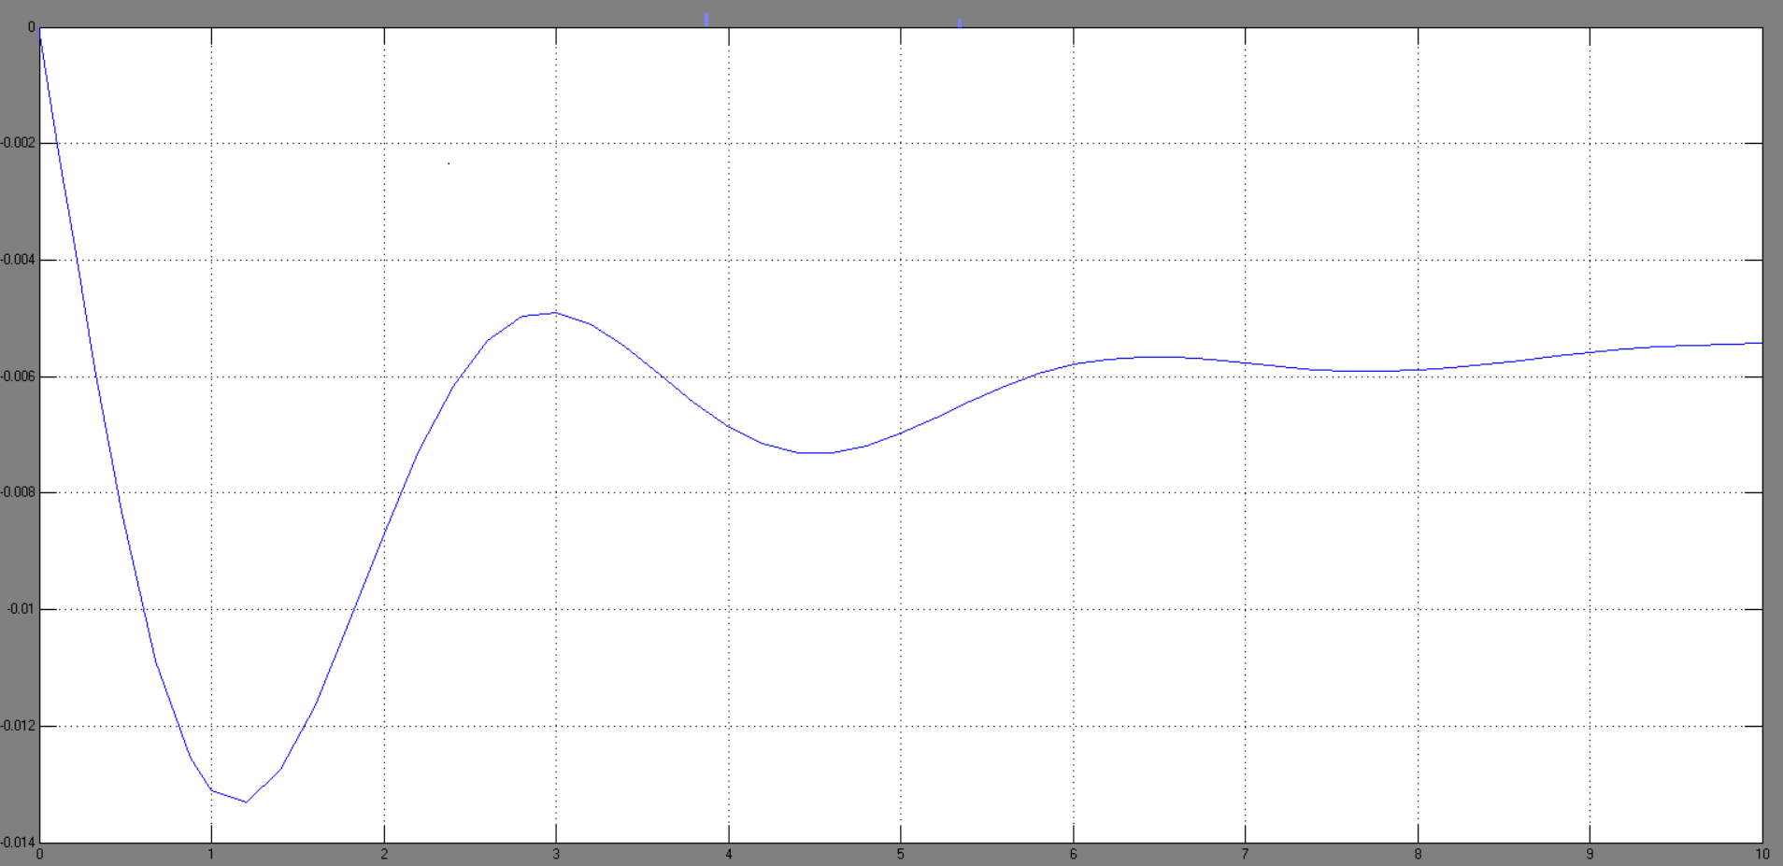Figure 4.3: Steady state change in frequency

This graph show the steady state change in frequency in per unit
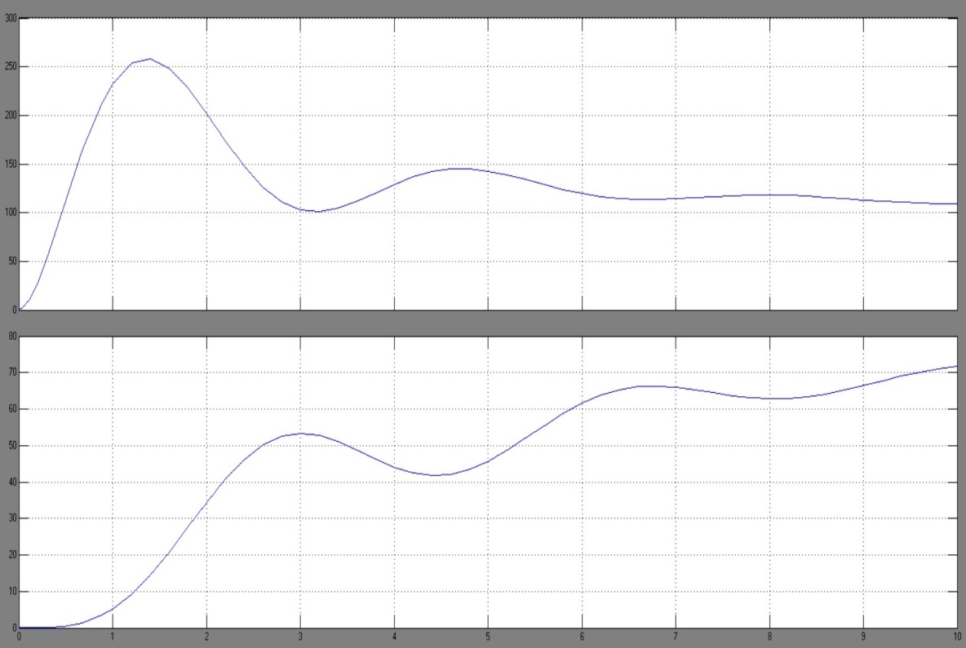
Figure 4.4: for change in mechanical power
This graph shows the change in mechanical power for first area and also the second area
Table 4.1: for two area load frequency control without controller
load change in area 1 ( ∆PL1) | 0.1875 pu
Steady state frequency deviation ( ∆f) | -0.25 hz
Steady stae frequency deviation (∆ $ω$ss) | -0.005pu
The new frequency (f) | 49.75 hz
Change in mechanical power area 1 (∆Pm1) | 0.10pu
Change in mechanical power area 2 (∆Pm2) | 0.080pu
Tie line power flow (∆P12) | -0.0845pu

4.3 CASE 1:
1.1 PID USING PSO
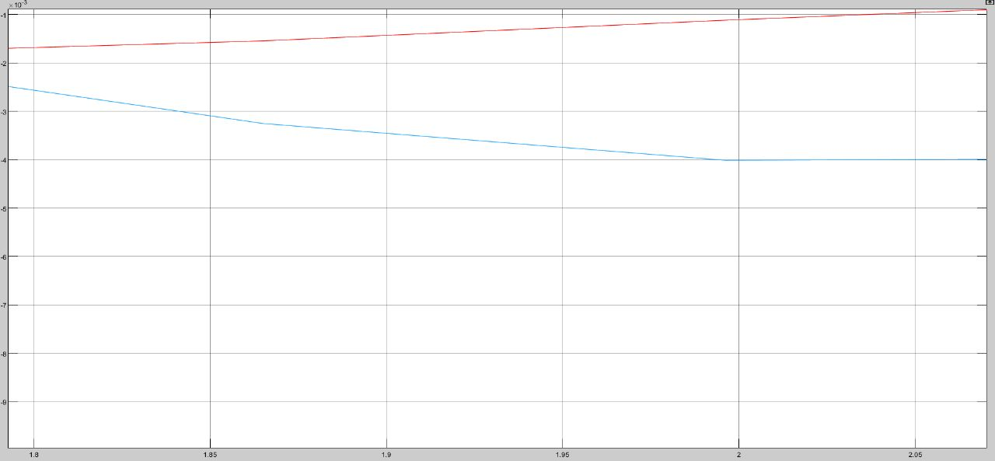
Figure 4.5: The first scenario response of LFC with PID using PSO
Table 4.2: Result for first case
Controller | ∆f | ITAE | SSE
PID USING PSO | -0.0002425 | 0.3356 | 0
PID USING PSO | -0.000666 | 0.5864 | 0

1.2 FUZZY LOGIC CONTROLLER
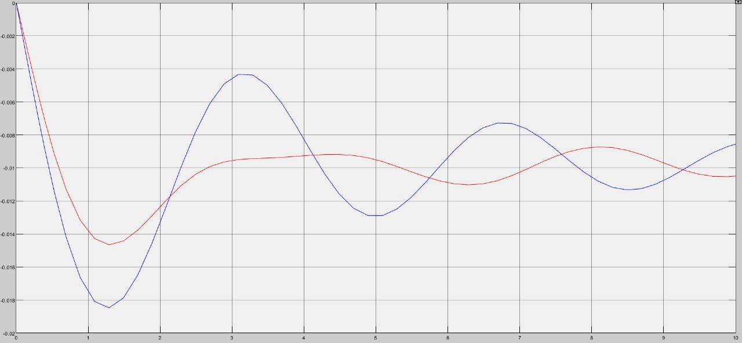
Figure 4.6: The first scenario response of LFC with using fuzzy logic controller
Table 4.3: Result for the first case
Controller | ∆f | SSE
Fuzzy Controller | -0.01049 | 0
Fuzzy Controller | -0.008563 | 0

4.4 CASE 2:
2.1 PID USING PSO
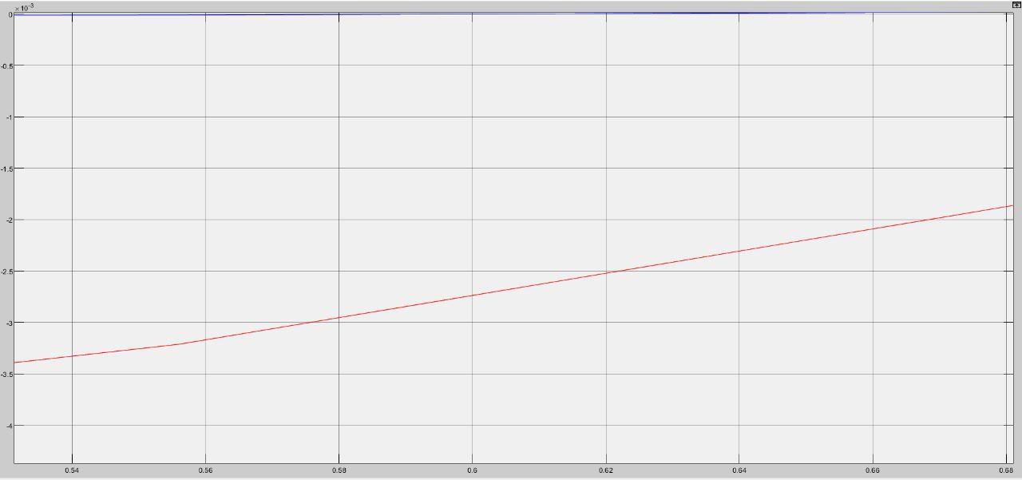
Figure 4.7: The Second scenario response of LFC with PID using PSO
Table 4.4: Result for the Second case
Controller | ∆f | ITAE | SSE
PID USING PSO | 0.0005225 | 0.3384 | 0
PID USING PSO | 0.0006944 | 0.02625 | 0

2.2 FUZZY LOGIC CONTROLLER
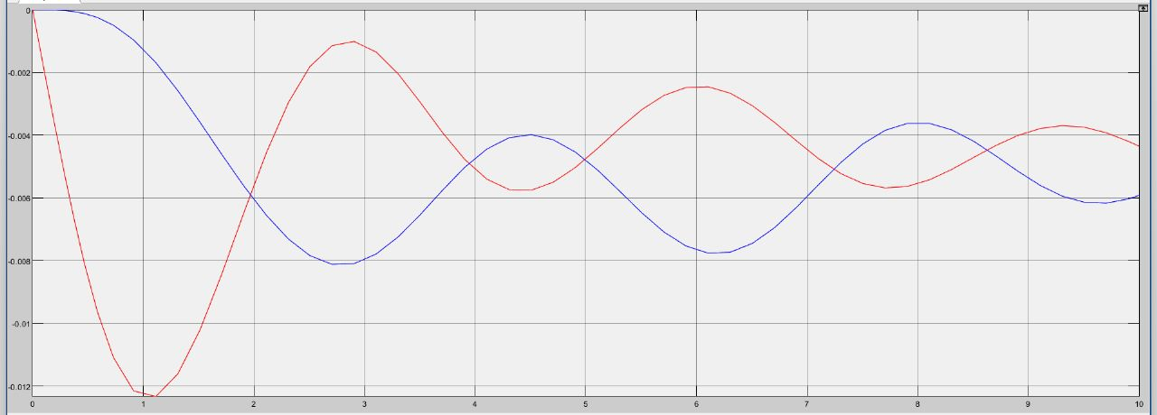
Figure 4.8: The Second scenario response of LFC with using fuzzy controller
Table 4.5: Result for the second case
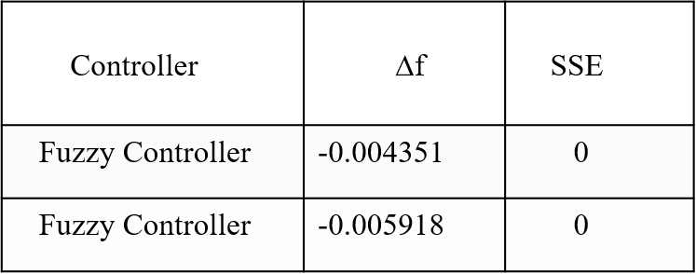
4.5 CASE 3:
3.1 PID USING PSO AND FUZZY LOGIC CONTROLLER (TWO AEA INPUT 200 MW)
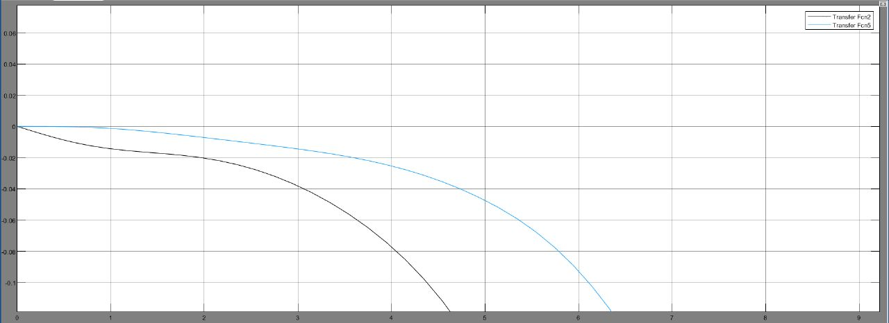
Figure 4.9: The Third scenario response of LFC with PID using PSO and Fuzzy logic controller
Table 4.6: Result for the Third case
Controller | ∆f | ITAE | SSE
PID USING PSO | -5.477 | 139.2 | 0
Fuzzy Controller | -0.8342 | - | 0
4.6 CASE 4:
4.1 PID USING PSO AND FUZZY LOGIC CONTROLLER (SINGLE AREA INPUT 200 MW)
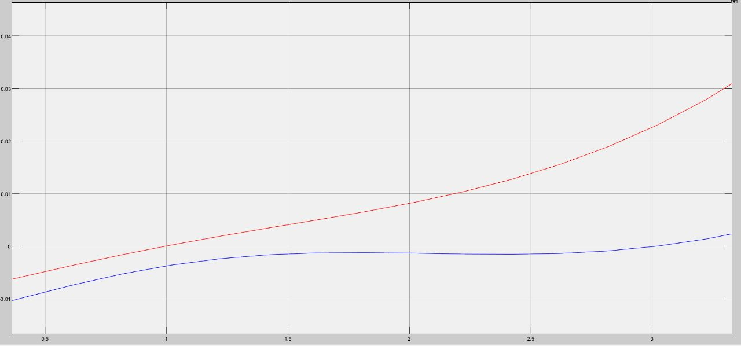
Figure 4.10: The fourth scenario response of LFC with PID using PSO and Fuzzy logic controller

Table 4.7: Result for the Fourth case
Controller | ∆f | ITAE | SSE
PID USING PSO | 1.192 | 29.67 | 0
Fuzzy Controller | 0.2881 | - | 0

4.7 RESULT FOR THE ALL THE CASES
Case Study | Controller Method | ∆f | ITAE  Best Fitness Function | SSE
First | PID USING PSO | -0.0002425,0.000666 | 0.3356,0.5864 | 0
First | FUZZY | -0.01049,-0.008563 | - | 0
Second | PID USING PSO | 0.0005225,0.0006944 | 0.3384,0.02625 | 0
Second | FUZZY | -0.004351,-0.005918 | - | 0
Third | PID USING PSO | -5.477 | 139.2 | 0
Third | FUZZY | -0.8342 | - | 0
Fourth | PID USING PSO | 1.192 | 29.67 | 0
Fourth | FUZZY | 0.2881 | - | 0
Table 4.8: Result for the All Cases

Where;
∆f: steady state change in frequency
SSE: Steady state error
ITAE: Integral Time multiplied by Absolute Error

First Case: both of two interconnected areas with same parameters using PID using PSO and FLC.
Second Case: both of two interconnected areas with different parameters using PID using PSO and FLC
Third Case: two interconnected areas with same parameters, the first area is controlled by PID using PSO while the second area with fuzzy controller.
Fourth Case: two interconnected areas with different parameters, the first area is controlled by PID using PSO while the second area with fuzzy controller.

4.8 SUMMARY
In this chapter simulation result and discussion for all the four cases of fuzzy logic and pid using pso controller and steady state frequency response is discussed.

CHAPTER 5
CONCLUSION
In this project, two extremely cutting-edge techniques were employed in place of the governor control system, which controlled load frequency. PID using PSO and fuzzy logic, which are frequently used in control, are the methodologies used. In control systems, PID using PSO and fuzzy logic are often employed techniques. In actual use, the effectiveness of these controls was evaluated against various scenarios in the two area-connected systems. The purpose of the study is to compare the performance aspects of PID using PSO and Fuzzy controllers for the two areas' interconnected power systems, which are examined using four different scenarios. Performance of the PID using PSO is demonstrated to be superior than fuzzy controller based applications for controlling the two area-connected power systems based on four separate simulation results. The findings of four separate situations with accompanying figures show that PID using PSO offer numerous advantages over the latter one, including a lower settling time (ts), and a lower oscillation.

